* **[Template]**

Pre-Conditions:

1. xxx

Main Success Scenario:

1. Xxx

Alternatives:

1. Xxx

* **Commit Changes to Git**

Pre-Conditions:

1. xxx

Main Success Scenario:

1. Xxx

Alternatives:

1. Xxx

* **Create Repository from Scratch in GitHub**

Notes:

1. Repo = Repository
2. Can have private and public repositories with paid account.
3. Can have only public repository with public account.

Pre-Conditions:

1. Free and Public repository.

Main Success Scenario:

1. Log into GitHub.
2. Click “+” at top right of GitHub screen and choose “new repository”.
3. Choose “Public”.
4. Click “Create repository”.
5. Open Git Bash on local machine.
6. Create directory for your repository using Git Bash.

**mkdir ~/dataScience**

1. Navigate to that new folder using Git Bash.

**cd ~/dataScience**

1. Initialize a local Git repository.

**git init**

1. Point local repo at remote repo that is on the GitHub server.

**git remote add origin https://github.com/yourUserName/dataScience.git**

* **Commanding Files in Git**

Note:

1. “workspace” is on the local machine.
2. “index” notes what files should be managed in version control.

Main Success Scenario:

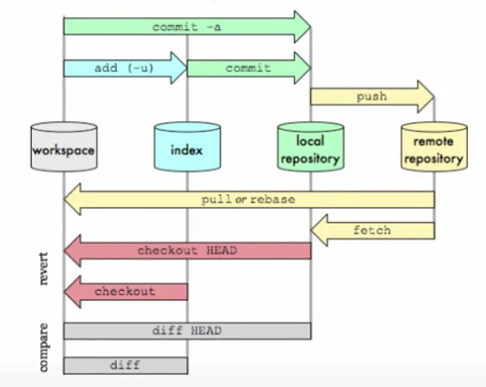

* **Get Help with Git or GitHub**

Main Success Scenario:

1. Help for Git

http://git-scm.com/doc

1. Help for GitHub

http://help.github.com/

* **Pull Copy of Repository from GitHub**

Pre-Conditions:

1. xxx

Main Success Scenario:

1. Xxx

Alternatives:

1. Xxx

* **Push Changes to GitHub**

Pre-Conditions:

1. xxx

Main Success Scenario:

1. Xxx

Alternatives:

1. Xxx

* **Setup Git**

Pre-Conditions:

1. Using Git on Windows.
2. For versioning on your local machine.

Main Success Scenario:

1. Go to <http://git.scm.com/downloads>
2. Click Windows icon
3. See if you have a 32 or 64 bit OS.
4. Get Git bit version that matches your OS bit version.
5. Install Git with default components.
6. Choose “Use Git from the Windows Command Prompt” on “Adjusting your PATH environment”.
7. Git installed.
8. Open git-bash.exe file
9. Set user name and email in bash window

**git config –global user.name “my user name”**

**git config –global user.email “your_email@email.com”**

1. Confirm changes

**git config --list**

1. Exit bash window

**exit**

* **Setup GitHub**

Note:

1. Allows for Git repository backup in the cloud.
2. Allows for pull of repository from the cloud.
3. Public is free. Private costs.
4. Multiple people anywhere in the world can work on the same project.

Pre-Conditions:

1. Setup Git

Main Success Scenario:

1. Go to <https://github.com>
2. Sign up for an account.
3. Enter User Name, email, and password. Use same email used in Git setup.
4. Choose free plan.
5. Read GitHub tutorials.